Name Of The Student | Garima Modiyani
Internship Project Topic | TCS iON RIO-210: Build a Classification Model for Drug Trials Dataset
Name of the Organization | TCS iON
Name of the Industry Mentor | jignasha royala
Name of the Institute | Amity University

Date | Day | Hours Spent
11-11-2025 | Day-33 | 4 hours 40 minutes
Activities done during the day:

Learn about the data modelling and model fitting.

Fitting the data to model.

What is Model Fitting?

- Model fitting is a measure of how well a machine learning model generalizes to similar data to that on which it was trained.
- The generalization of a model to new data is ultimately what allows us to use machine learning algorithms every day to make predictions and classify data.
- The definition of a good model fit is one that accurately approximates the output of an unknown input when it is provided with unknowable inputs.
- A model’s fitting is the process of adjusting its parameters in order to improve its accuracy.
- In order to generate a machine learning model, a machine learning algorithm is run on data for which the target variable (“labeled” data) is known.

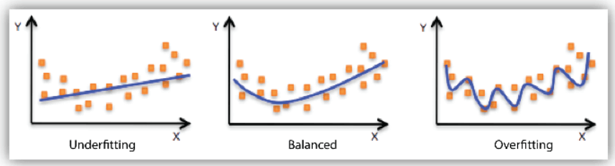

- the model’s results are compared with the real, observed values of the target variable.
- The next step is to adjust the algorithm’s standard parameters in order to reduce the error level and make the model more accurate.
- In order to make accurate predictions, the model must repeat this process several times.
- The cause of poor performance in machine learning models is either overfitting or underfitting the data.
- A well-balanced model produces more accurate outcomes.
- A model that is overfitted matches the data too closely. A model that is under fitted doesn’t match closely enough.

Why is Model Fitting important?

- Understanding model fit is important for understanding the root cause of poor model accuracy.
- In fact, overfitting and underfitting are the two biggest causes of the poor performance of machine learning algorithms.
- Hence, model fitting is the essence of machine learning.
- If our model doesn’t fit our data correctly, the outcomes it produces will not be accurate enough to be useful for practical decision-making.
- Model fitting is an automatic process that makes sure that our machine learning models have the individual parameters best suited to solve our specific real-world business problems accurately.

Reference:

https://www.datarobot.com/wiki/fitting/#:~:text=What%20is%20Model%20Fitting%3F,matches%20the%20data%20too%20closely./

